Demonstrate Knowledge of Layers and Masks (Domain 3.2)

The Layers panel in Photoshop displays layers, layer effects, and layer groups that make up the image and is one of the most used panels. Here you can control the appearance of the image as you create new layers, add layer effects, organize layers, apply blending modes, and show and hide layers.
Layers are arranged in the Layers panel; the layer order determines the appearance of effects and elements in each layer. The top layer in the stack appears in the front of the image, and effects may appear differently based on the order in which they appear. To move a layer in the stack, click and drag the layer to its new position. To delete a layer, select the layer, and then click the Delete button in the Layers panel.
To rename a layer, double-click the layer name in the Layers panel, and then type the new name. It is a good habit to name your layers. Naming layers helps you locate a layer more quickly and easily as your project begins to grow. Another way to manage a large project is to organize layers in groups by clicking the New Group button in the Layers panel. Existing layers can then be dragged into the group, or new layers can be added with the Create a New Layer button. You can link layers by selecting two or more layers and then clicking the Link Layers command on the Panel options menu. Linked layers are designated with a link icon and can have transformations applied to them.
Clicking the Indicates Layer Visibility icon hides the layer, a style, or a group from view. This allows you to work on another layer without distraction, or to hide a layer effect to assess its effect on your image. To quickly show or hide all layers in the stack; right-click the Indicates Layer Visibility icon at the top of the stack.
When you have completed work on your graphic design project, you often want to compress your layers into a single layer to reduce the file size. Click the Panel options menu, and then click Merge Layers to reduce the selected layers into one layer. Note: Once you save a document with merged layers, you cannot undo your actions to the unmerged state. The Flatten Image command, also found on the Panel options menu, merges all visible layers and discards any hidden layers. You cannot undo a file saved with flattened layers to an unflattened state.
By adding a mask to a layer, you can hid or reveal portions of the image in the layer that is beneath it in the Layers panel. You can create a layer mask or vector mask; both appear as a thumbnail in the Layers panel to the right of the layer thumbnail. A layer mask is dependent on the resolution of the bitmap images. You can edit it using painting or selection tools. To add a layer mask to the selected layer, click the Add Layer Mask button in the Layers panel, or click the Add a Pixel Mask button in the Masks layer. A vector mask is independent of the resolution and is created using the Pen tool or a drawing tool. To create a vector mask, select a drawing tool in the Tools panel, click the Add a vector mask button in the Masks panel, and then draw a shape. Note: You can also create a vector mask when drawing a shape by clicking the Shape Layers Button on the options bar, which creates a layer mask when the shape is drawn with the foreground color.
A layer mask is a grayscale image that you can edit with black, white or shades of gray. When you draw on the layer mask with the black as the foreground color, the object creates a “hole” in the image, allowing pixels in the Layer below it to show through. Drawing with white does not allow the layer below to be visible. Drawing with shades of gray creates different levels of transparency for the layer below to blend with the masked layer. The Masks panel allows you to make additional adjustments to the mask. You can edit a mask with the painting tools or with a drawing tool by first clicking the Fill Pixels button on the options bar. To edit a mask, you first need to select it by clicking the mask thumbnail in the Layers Panel or by clicking the Select Pixel Mask button in the Masks panel.
You can also add a blending mode to an image to change how pixels in the selected layer blend with pixels in same location in the layer just below it. To select a blending mode, click the Blending mode pop-up menu in the Layers panel, and then click a blending mode.

Domain 3.2 Step by Step Activity

- Open the LAKE SEPIA file from Step-by-Step activity 3.1.
- Click FILE on the Application bar, click SAVE AS, name the file LAKE COLOR CORRECTED, and then click SAVE.
- On the Application bar, click the Essentials button, and then in the Tools panel, click the Move tool.
- In the Layers panel, click the HUT/SATURATION layer if necessary, and then click the DELETE LAYER button, and then click YES to delete the layer.
- Click the BACKGROUND layer, and then drag it on top of the CREATE A NEW LAYER button to duplicate the layer. The new layer is named Background copy.
- With the Background copy layer selected, click the ADJUSTMENTS panel, and then click the HUE/SATURATION icon.
- Click the SELECT A HUE/SATURATION PRESET pop-up menu, and then click SEPIA.
- In the Layers panel, with the Hue/Saturation layer selected, click the PANEL OPTIONS menu button, and then click MERGE DOWN. The Hue/Saturation layer is merged with the Background copy layer. The Background copy layer is altered permanently to a sepia color.
- Click the BACKGROUND COPY layer if necessary, and then at the bottom of the panel, click the ADD LAYER MASK button. A layer mask thumbnail appears next to the Background copy thumbnail.
- In the Tools panel, click the DEFAULT FOREGROUND AND BACKGROUND COLORS button to reset the default colors to black-and-white. If necessary, click the SWITCH FOREGROUND AND BACKGROUND COLORS button to make the foreground color black.
- In the Tools panel, click the RECTANGULAR MARQUEE tool, and the draw a selection with the rectangular marquee in the image. The marquee creates a mask.
- In the Tools panel, click and hold the GRADIENT tool. If necessary, click the PAINT BUCKET tool; click the POINTER inside the selection in the Document window. The original colors are visible within the selection.
- Click SELECT on the Application bar and then click DESELECT.
- In the Layers panel, click the BLENDING MODE pop-up menu, click VIVID LIGHT. Depending on the colors in the top layer, the Vivid Light blending mode increases or decreases the contrast in the lower layer. In this case, the sepia colors are darkened, which creates a framing effect.
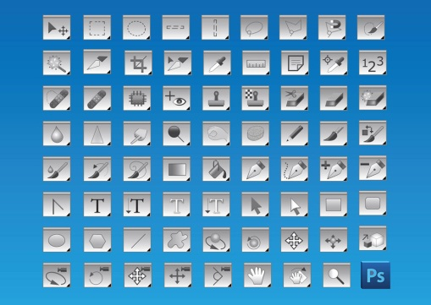
- Save and close the document.

